NEOSTEL

Tipo Doc.:  Doc.Type: | Detailed Design Document |  |  |  |  | N° DRD:  DRD N°:
N° Doc.:  Doc. N°: | NEOSTEL-DD-CGS-005 | Ediz.:  Issue: |  | Data:  Date: |  |  | Pagina  Page | 1 | Di  Of | 17
Titolo :  Title : | CCD & Camera Assembly Detailed Design and Analysis

 | Nome & Funzione  Name & Function | Firma  Signature | Data  Date |  | LISTA DI DISTRIBUZIONE  DISTRIBUTION LIST | N | A | I
Preparato da:  Prepared by: | Piotr Zdunek | CTI | 03.12.2014 |  | Interna / Internal
Approvato da:
Approved by:
Applicazione autorizzata da:  Application authorized by: |  |  |  |  | Esterna / External
Customer / Higher Level Contractor
Accettato da:
Accepted by:
Approvato da:
Approved by:
N=Numero di copie A=Applicazione I=Informazione
N=Number of copy A=Application I=Information

Gestione documenti:
Data Management:
Gestione documenti:  Data Management: | Firma / Signature Data / Date |  | File: | NEOSTEL-DD-CGS-005_sw_hdl (1).doc

REGISTRAZIONE DELLE MODIFICHE / CHANGE RECORD
EDIZIONE  ISSUE | DATA  DATE | AUTORIZZAZIONE  CHANGE AUTHORITY | OGGETTO DELLA MODIFICA E SEZIONI AFFETTE  REASON FOR CHANGE AND AFFECTED SECTIONS
1 | 03/12/2014 |  | First Issue

LISTA DELLE PAGINE VALIDE / LIST OF VALID PAGES
PAGINA  PAGE | EDIZIONE  ISSUE | PAGINA  PAGE | EDIZIONE  ISSUE | PAGINA  PAGE | EDIZIONE  ISSUE | PAGINA  PAGE | EDIZIONE  ISSUE | PAGINA  PAGE | EDIZIONE  ISSUE
1 - | 1

TABLE OF CONTENTS

1. Introduction 5
1.1 Document SCOPE and Organization 5
1.2 Acronyms 5
1.3 Applicable Documents 5
1.4 Reference Documents 5
2. Section 6

LIST OF FIGURES

Non è stata trovata alcuna voce dell'indice delle figure.

LIST OF TABLES

Non è stata trovata alcuna voce dell'indice delle figure.

Introduction
This document presents specification regarding software and digital system design of Neostel CCD Camera system. Description of the camera system is presented in Section 2, as well as the current state of the project. Section 3 contains a detailed system behaviour specification in regards to operating system.

Document SCOPE and Organization

Acronyms
AD | Applicable Document
CGS | Compagnia Generale per lo Spazio (formerly Carlo Gavazzi Space)
NEOSTEL | NEO Survey Telescope
FPGA | Field Programmable Gate Array
SoC | System on a Chip
CCD | Charged Coupled Device
GbE | Gigabit Ethernet
PTP | Precision Time Protocol IEEE1588
EPICS | Experimental Physics and Industrial Control System
FITS | Flexible Image Transport System
MP | Mega Pixel
AMP | Asymmetric multiprocessing
RTOS | Real-time operating system
SFP | Small form-factor pluggable
AFE | Analog Front End
IP core | Intellectual property core
SPI | Serial Peripheral Interface
I2C | Inter-Integrated Circuit bus
CAN | controller area network
Uboot | DENX Universal Bootloader
USB | Universal Serial Bus
DDR3 | Double data rate RAM, third generation
RAM | Random access memory
UART | universal asynchronous receiver/transmitter
SD | Secure Digital memory card standard
QSPI | Quad SPI
NFS | Network File System protocol
SCADA | supervisory control and data acquisition

Applicable Documents
- Statement of Work P2-NEO-V ‘NEO Survey Telescope Detailed Design’, SSA-NEO-TEL-SOW-0001, Issue 1, 17/12/2013
- Space Situational Awareness - NEO System Requirements Document, SSA-NEO-RS-RD-0001, Issue 1, Revision 4, 05/04/2013
- CGS Proposal “NEO Survey TELescope Design NEOSTEL”, S14-003 Is.1, April 2014

Reference Documents
- TELAD Design Report, TELAD-RP-CGS-001, version 1, 25/10/2011

General SPECIFICATION
This section describes general system behaviour from the software and digital system point of view.
2.1 System diagram
Illustration 1: System diagram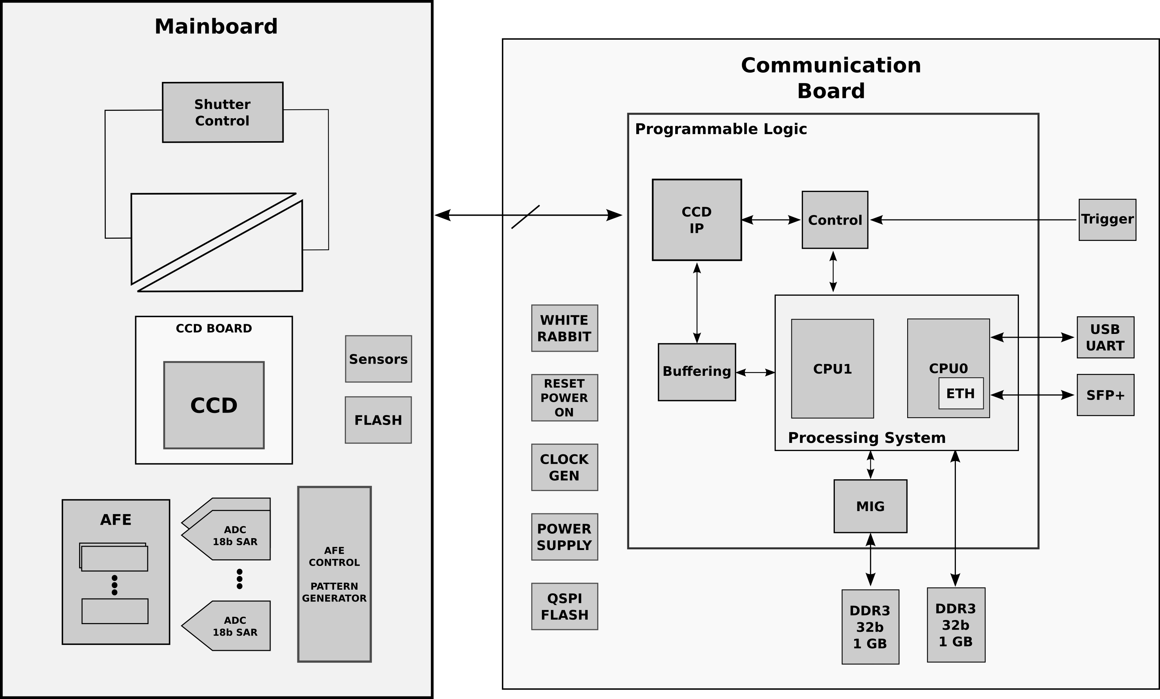
Illustration 1 provides a general overview of camera system. Mainboard with a CCD sensor and peripherials is connected to the Communication Board which controls the whole system.

2.2 DescriPTion
The system described in this document should be treated as a standalone control and measurement system in form of an intelligent camera with broad spectrum of instruments to interface at the facility level.
The hardware is based on Xilinx Zynq SoC, which incorporates two core Cortex A9 application processors and an FPGA in one package. It also contains a number of integrated peripherals like Ethernet, SPI, I2C, CAN, USB etc. and an DDR3 memory controller.

System runs both Linux and RTOS operating system in an AMP scenario. Linux is responsible form high level control and maintenance and RTOS for time critical tasks.

Communication is based on Ethernet. It provides microsecond synchronisation capability due to the use of PTP synchronisation. Also RS485 is used in the system as a standard console output.

Interface for CCD sensor analogue front-end and shutter mechanism is implemented entirely in logic in order to provide exact timing control.

System is controlled via EPICS with implemented server functionality. The picture data will be double buffered and sent in FITS format to remote facility server.

2.3 System Features
- Low noise 16MP CCD sensor readout
  - pictures are in self describing FITS format with additional diagnostic information
- Shutter control with accurate start/stop position feedback implemented in FPGA
- Environment measurements (humidity, temperature, position)
- EPICS SCADA support with EPICS server implementation for system diagnostics and control
- High speed interface: 1 Gbps Full Duplex Ethernet through SFP transceivers with full hardware PTP support including hardware timestamping
- Internal and external trigger
- Time synchronisation via PTP
- Heterogeneous system with both RTOS for critical procedures and Linux for interfacing flexibility and easy data processing with low latency control and diagnostics path
- Universal CCD data readout with flexible FPGA logic and modular AFE
- Innovative Xilinx Zynq design with dual core Cortex A9+ and FPGA on one die with shared subsystems

Specification
This section descibes the specification of Neostel camera system with a detailed diagrams of system behaviour.

3.1 Operating system

3.1.1 architecture
Illustration 1: Camera operating system architecture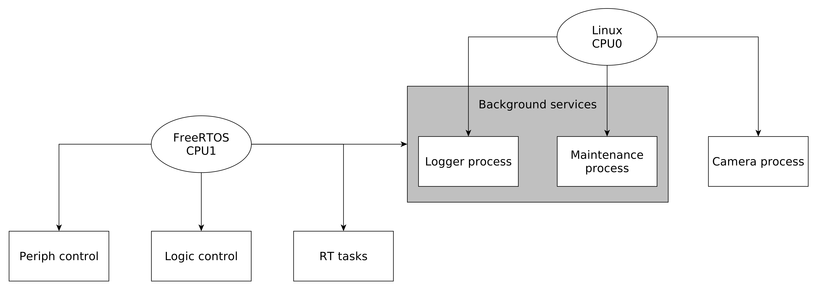

Camera is running two operating systems. An embedded Linux system and a RTOS. First is used for communication and control of the whole system and RTOS is used for time critical tasks.

SoC that is used in this design is a two core unit which supports AMP operation. This way one core is used for Linux and other is for RTOS.

3.1.2 BOOT Sequence
Illustration 1: Boot system diagram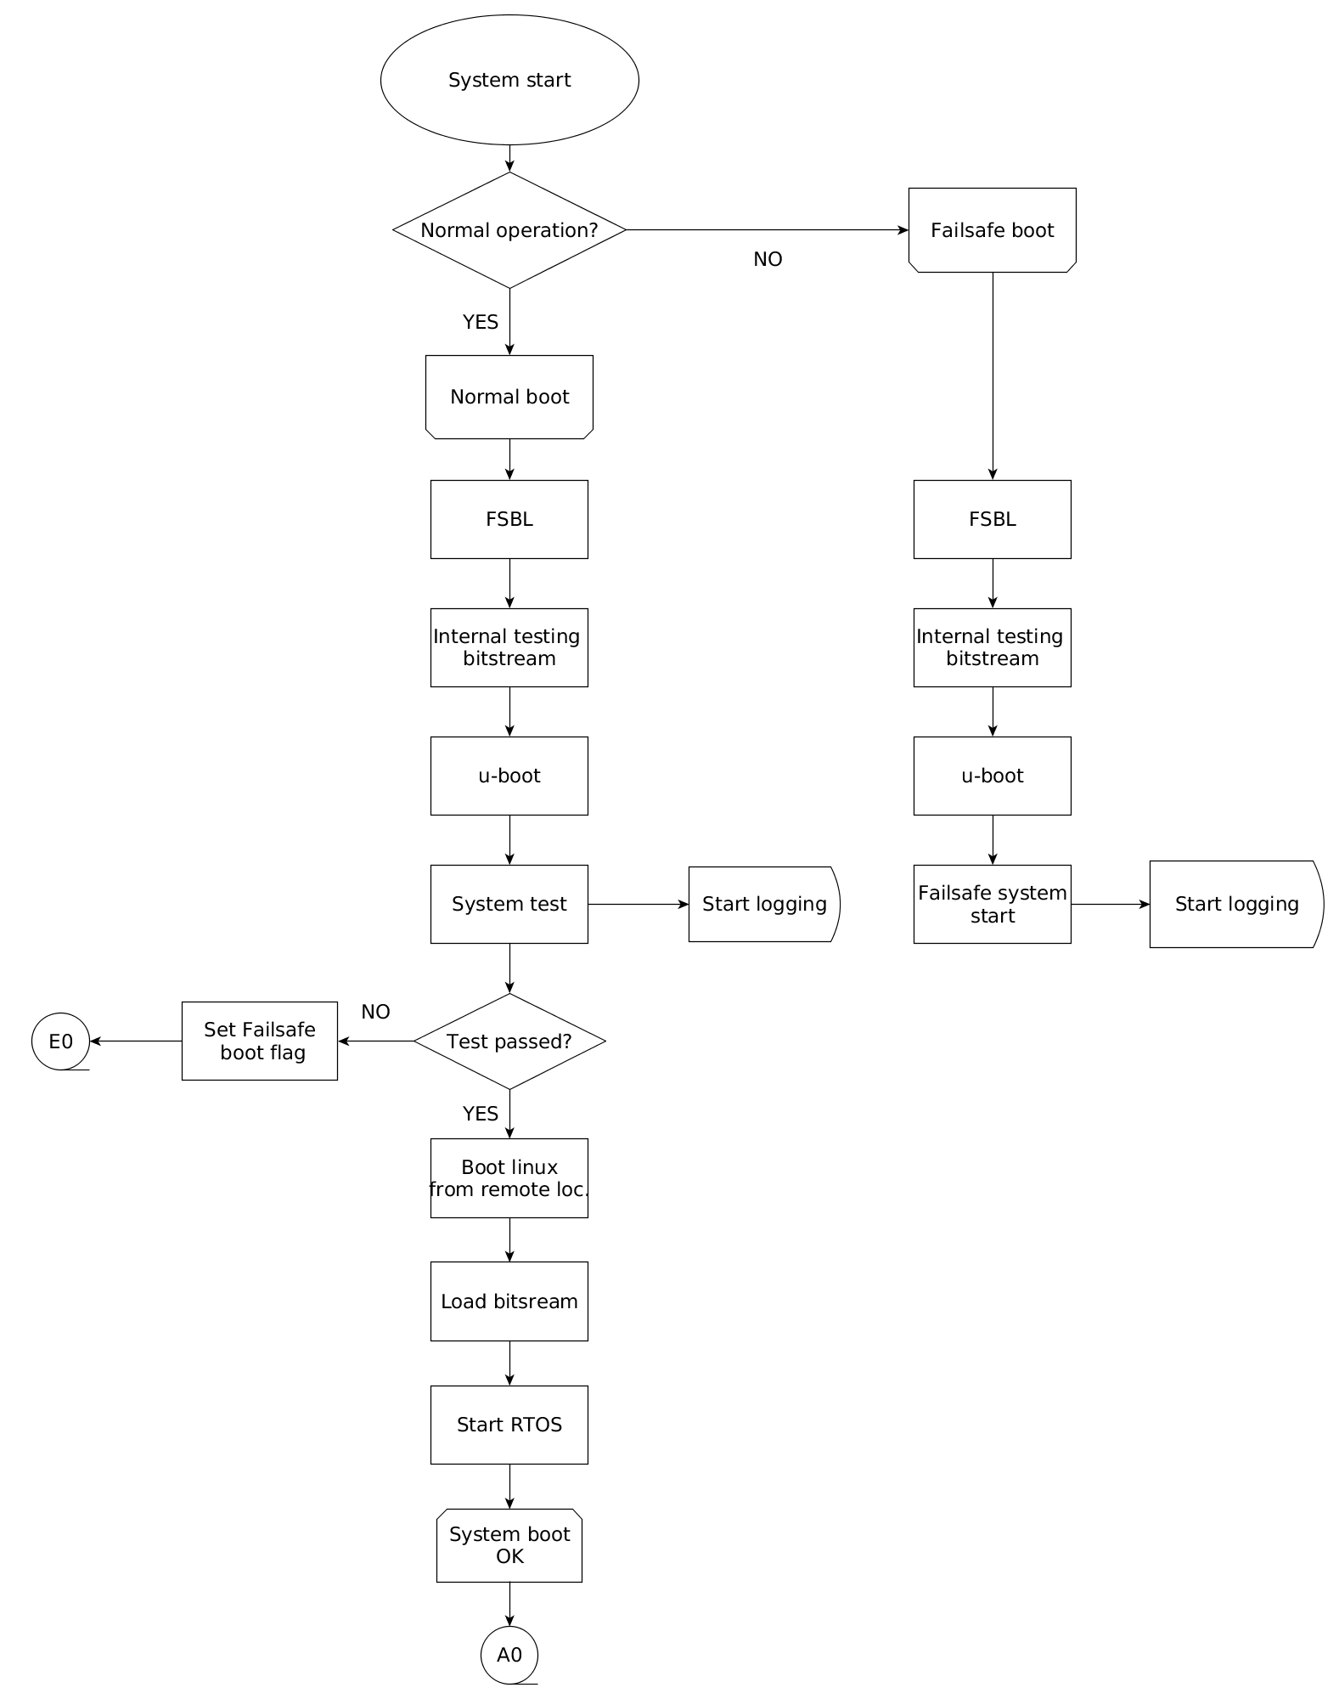

When input power is applied to camera, the system starts booting. Initial boot sequence works as pictured on a diagram.
Boot sequence incorporates initial system test. Basic peripherials needed for operation are checked. Because of the fact that the system is a multi-camera design, the operational system image is stored remotely. (e.g. on a server available via NFS).
Initially a testing version is booted from QSPI Flash memory, if the initial test has passed, the remotely available image is loaded and system is restarted. In the second scenario a fail-safe system version is booted.
Initial testing will be done using uboot procedures. All of the diagnostic output during boot is logged on SD card attached on the designed board to enable future problem tracing and debug possibilities.

3.1.3 Linux start
Illustration 1: Linux OS start sequence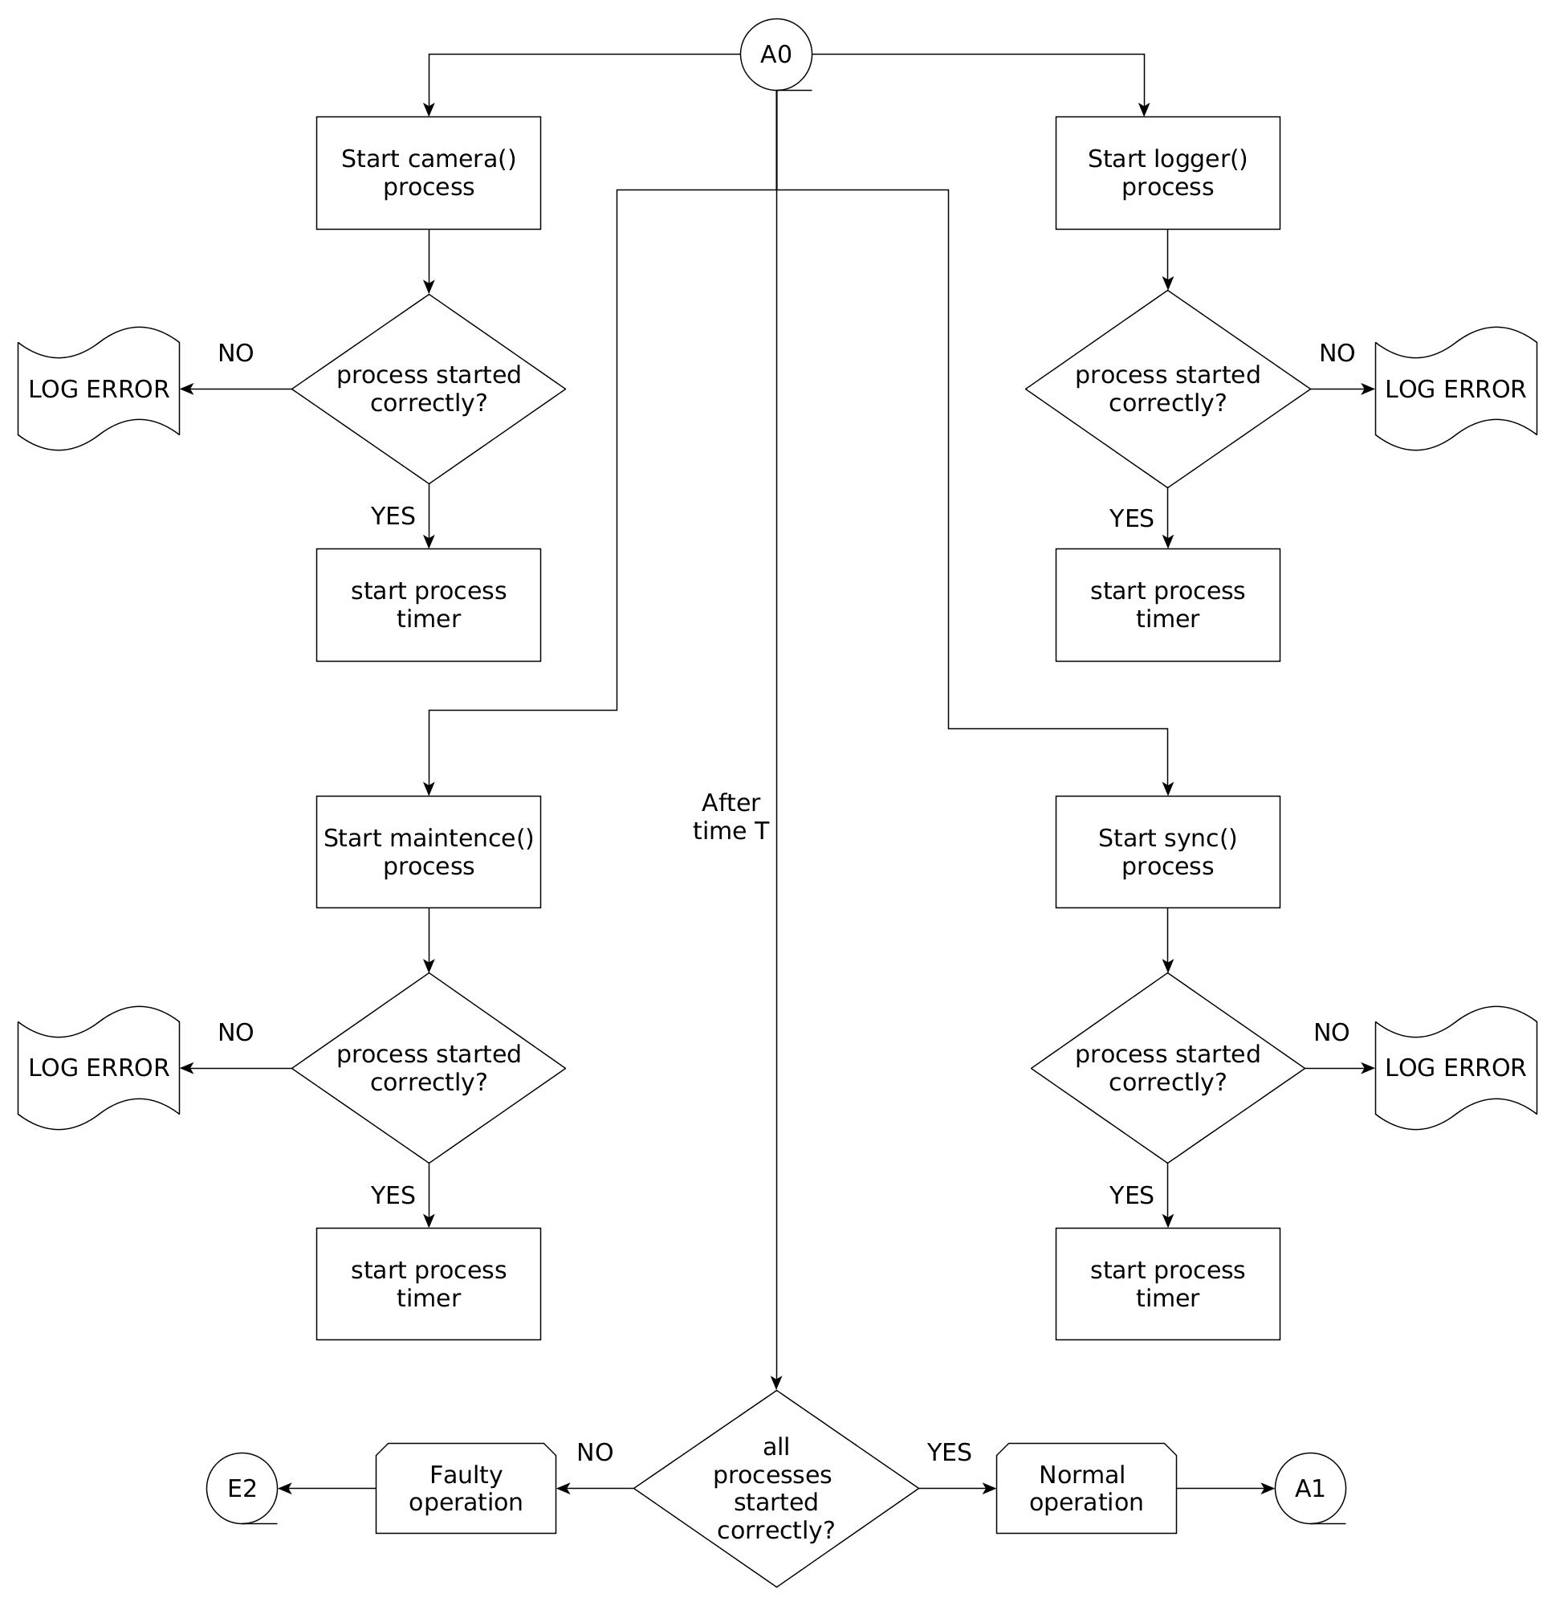
After correct boot procedure Linux OS starts all processes needed for proper operation. This processes are responsible for controlling all peripherials and CCD data acquisition. At this moment normal embedded Linux OS is running and all typical applications and access methods such as ssh are available. Logs are stored internally on SD Card and additionally they can be send via EPICS to the control system or viewed through serial console. If all processes started correctly system is moving into A1 state, which is normal operation. In the second scenario the system goes into E2 state which means that some subsystems are not fully operational.

3.1.4 Operating system normal operation
Illustration 1: Linux operation diagram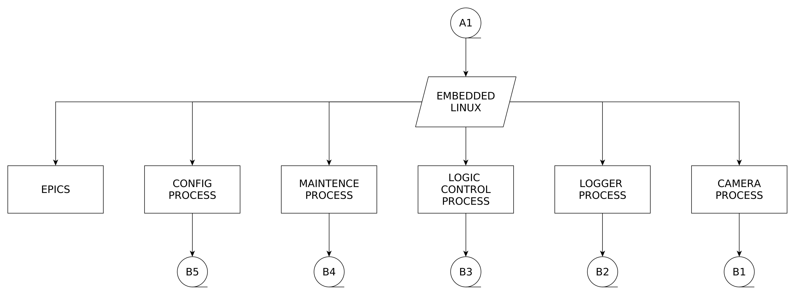
Ilustration 5 shows the normal system operation. Embedded Linux is running along with all processes. EPICS control is using processes and programs that control all of the peripherials.

At this point system can be controlled via EPICS or manually by logging directly on the system.
Initial setup script that is being run at the beginning of the boot sequence provides default configuration for the device.
The processes that are running on the camera are responsible for:
- maintenance – checking all peripherals and runtime behaviour
- configuration – for set-up of camera configuration
- logic control – IP Cores control and set-up
- logging – storing all system behaviour
- camera control – pictures acquisition, shutter and readout control

3.1.5 Camera process
Illustration 1: Camera process beahaviour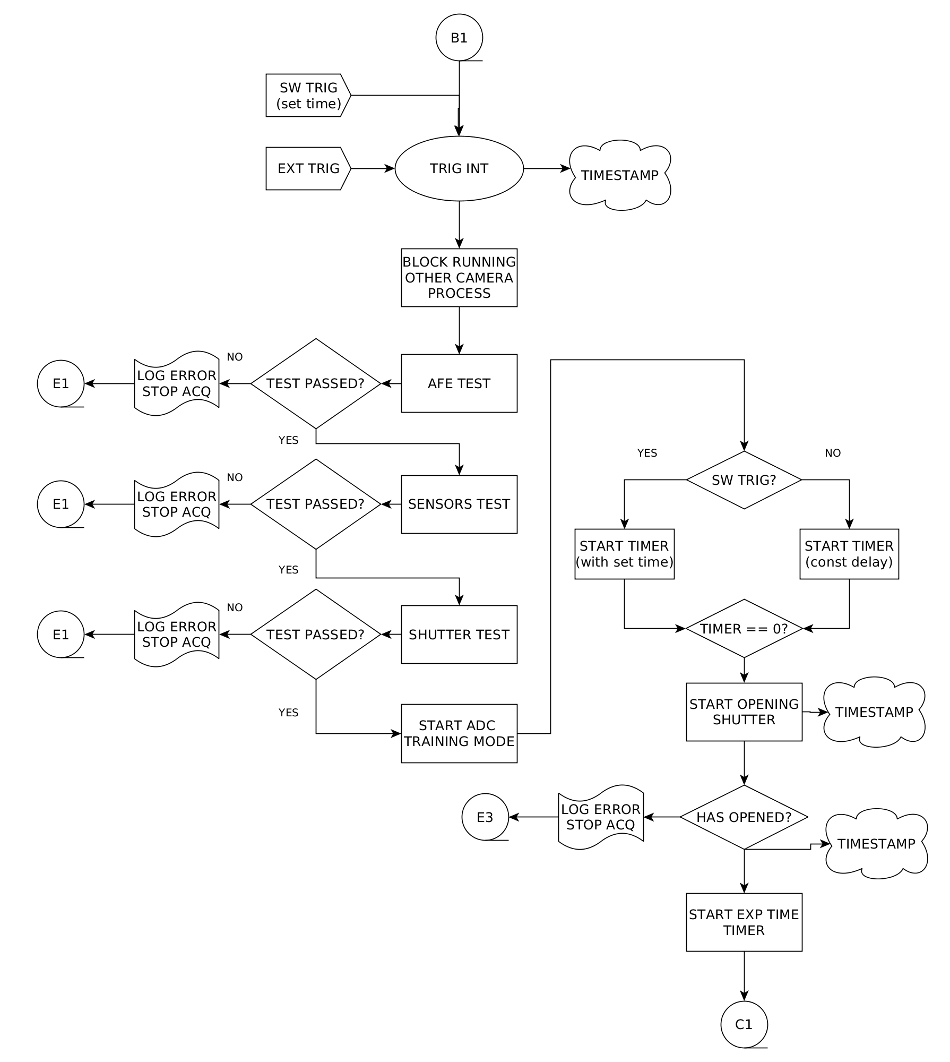
Ilustration 6 shows the system behaviour when the picture trigger is started. First basic testing is run to check if all systems are operational. Then shutter opening is started.

3.1.6 Camera Process continued
Illustration 1: Camera process behaviour after opening the shutter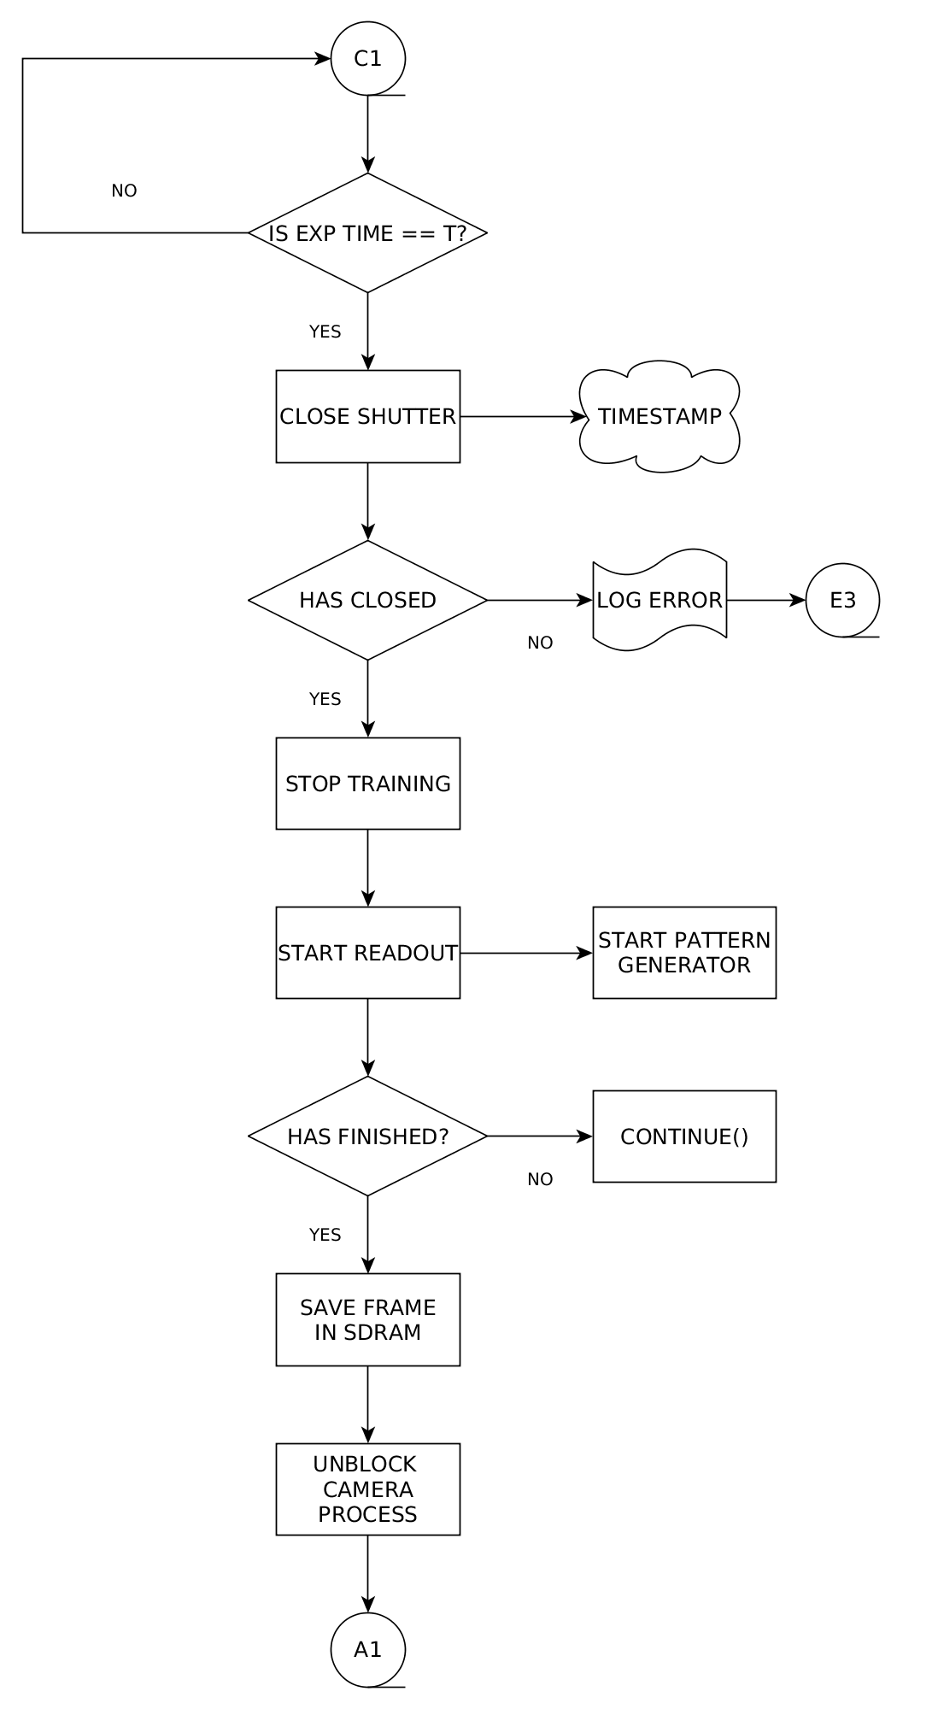

Shutter opening and CCD readout is timestamped. Along with time, the sensor data are stored for each timestamp. Timestamping itself is done in processing system. The precision of this approach is equal to approx. 3 us. After shutter opening exposure time is measured and when it's finished shutter closure procedure is started. Both opening and closing of shutter can fail, in this scenario camera process is terminated and disabled.

3.1.7 Other processes
Illustration 1: Operation of other processes running in background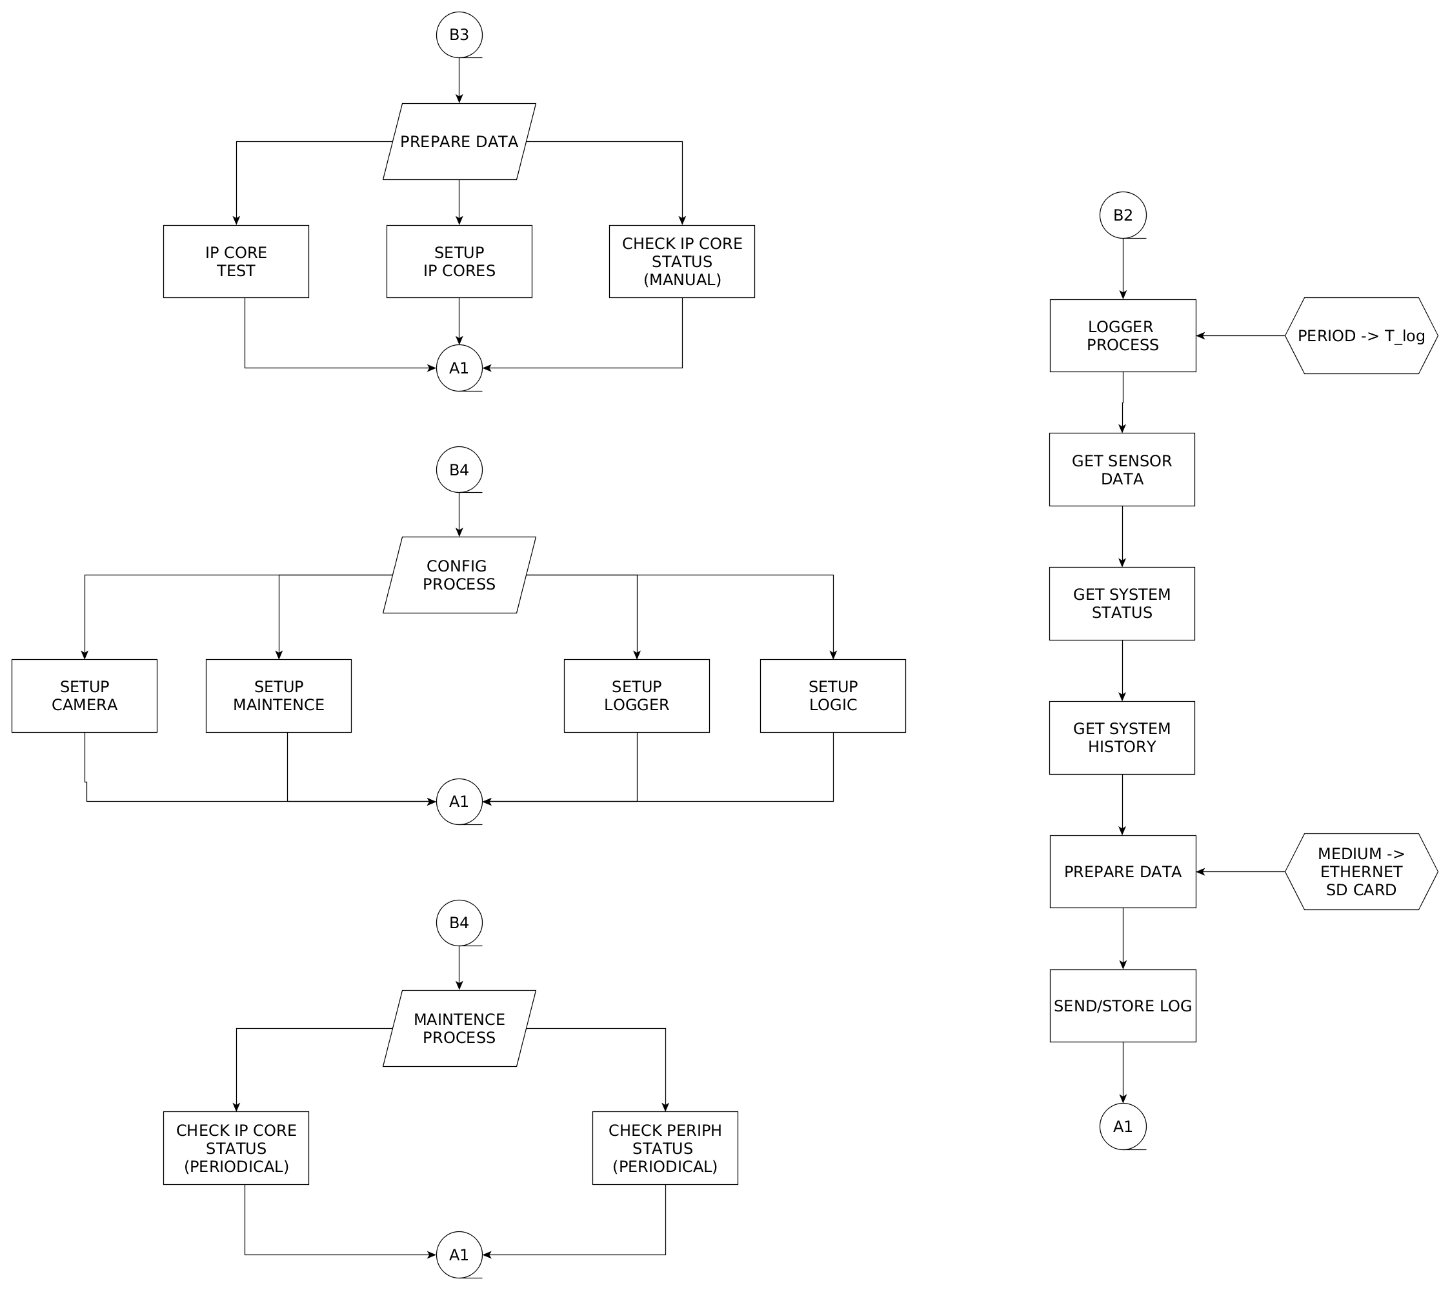

3.1.8 Error handling
Illustration 1: Erronous operation diagrams